Profiling Climate Change
Name
Institution

Anthropogenic climate change
Anthropogenic climate change refers to human activities that contribute to a change in climate and variations in the earth's atmosphere and the number of greenhouse gases, e.g., carbon dioxide, methane released, and cloudiness. The major cause of anthropogenic climate change is global warming.
Natural Greenhouse effect versus anthropogenic greenhouse effect
The natural greenhouse effect occurs as a result of the warming of the troposphere with natural greenhouse gases. The greenhouse gases are gases found in the atmosphere that can allow the sun's direct radiation but prevents and absorbs the Earth's thermal radiation at certain wavelengths.
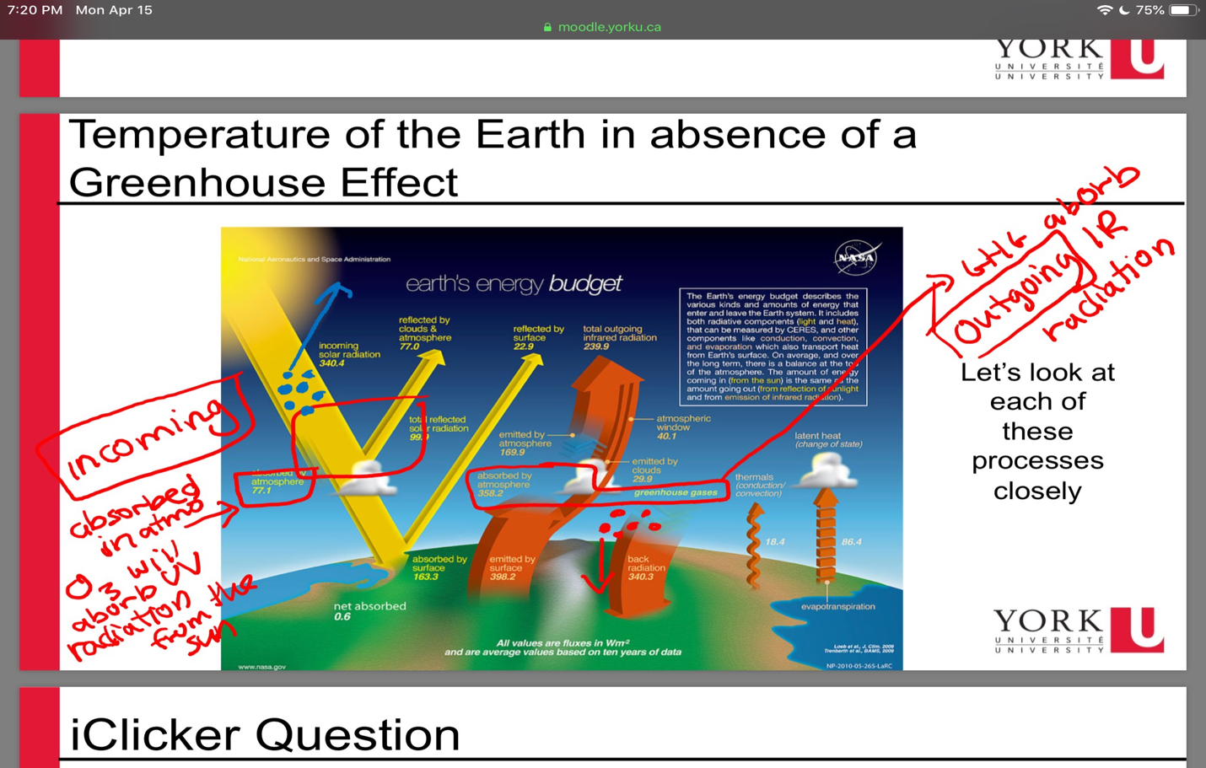

On the other hand, the anthropogenic greenhouse effect occurs from energy-related activities such as the burning of fossil fuels, emission of fumes from vehicles and industries releasing carbon dioxide into the atmosphere, waste management activities, and a change in land use.
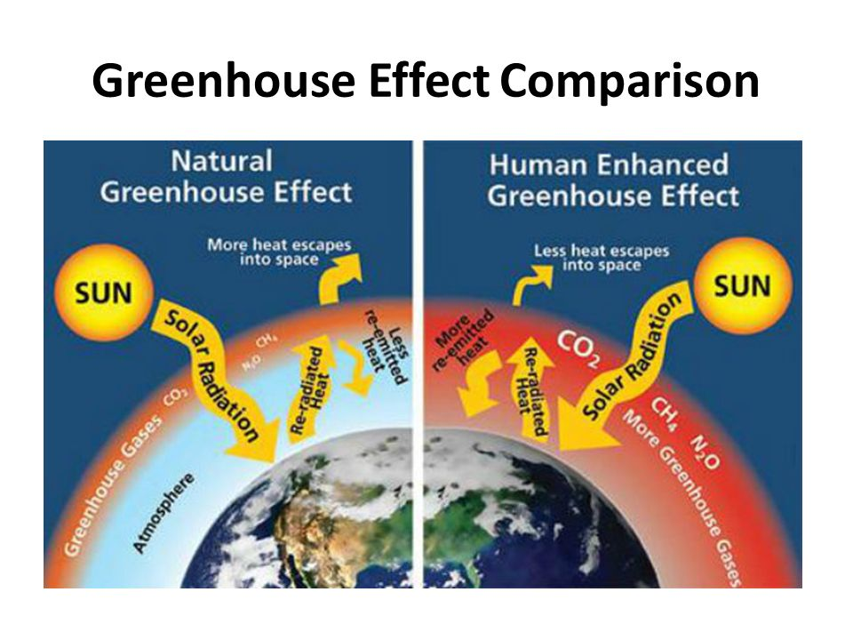

Importance of Natural Greenhouse Effect
The greenhouse gases which include carbon dioxide, methane, and nitrous oxide, are important in maintaining a balance between the energy released directly from the sun and the energy emitted to the earth. The gases trap gases from the earth naturally or through human activities into the atmosphere hence retaining heat. The heat results in a change in the heat balance of the earth, resulting in a change in global and regional climatic patterns.

Global Warming
It refers to increased greenhouse temperatures caused by increased concentrations of anthropogenic gases and aerosol particles such as black carbon. Carbon dioxide gas is the leading cause of global warming. The figure below shows how the layer of greenhouse gases in the atmosphere gets thicker to absorb more heat. This increases the temperatures on earth, and it gets hotter and hotter.

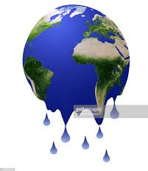

Effects of climate change on living things and natural systems.
The climate change rate has increased currently due to industrialization. The amount of carbon dioxide released has been a major concern in the world. The alterations in climate pose a threat to aquatic organisms, living microorganisms, and natural systems. This means that climate change affects the atmosphere, lithosphere (the solid part of the earth), biosphere (plants and animals), and the hydrosphere (water bodies and aquatic animals). The effects include;
- Climate change will result in accelerated sea levels caused by global warming, as shown in the figure.
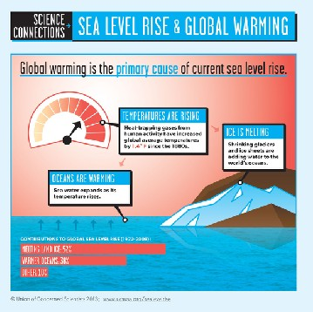

- In some other regions of the world, like the Arctic, climate change has led to the poles' hardening. This results in melting and loss of sea ice, as shown in the figure below.

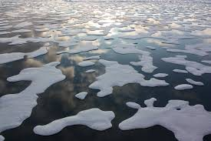
- Climate change has resulted in soil degradation and desertification in many parts of the world, resulting in food insecurity.
- Climate change has stood to be a danger to human well-being. The gases release have been associated with diseases like cancer.
- Death of aquatic animals and migration of fish. Temperature increases have reduced oxygen in water bodies, and cold-water fish such as the salmon are becoming inactive. This also affects the fishing patterns (Miller et al., 2018).

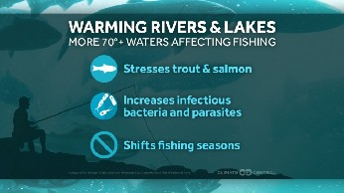

Developing countries will be affected economically. According to (Khan et al. 2019), climate changes have a long-lasting impact on a country's economy. The growth per capita is affected by an increase in temperatures in a country. The survival of infants in developing countries is also affected (Geruso &Spears, 2019).

The figure below summarises the causes and effects of global warming and climate change.
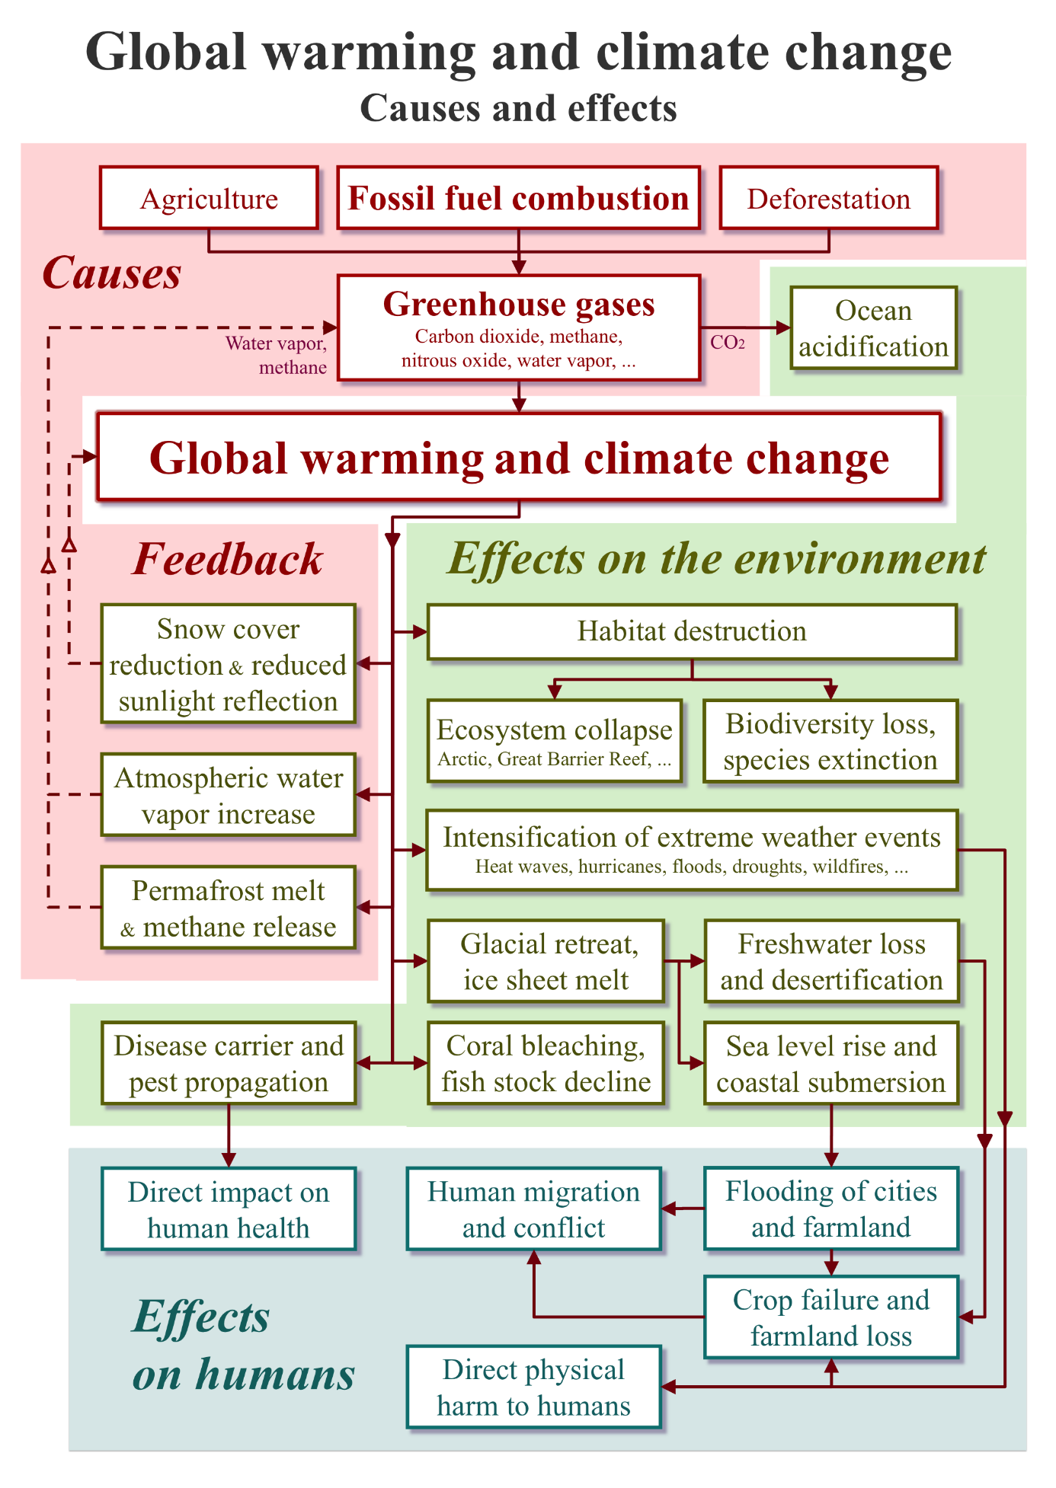
Effects of Human Activities on Climate change
- Deforestation-this affects the balance of carbon dioxide in the atmosphere since trees absorb the gas and release oxygen. Human beings have been cutting down trees to build infrastructure (Longobardi et al.,2016)

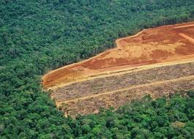

- The burning of fossil fuels has led to increased greenhouse gas levels in the troposphere, hence leading to heating up of the globe.
- Fumes released from industries result in high concentrations of carbon dioxide in the atmosphere.

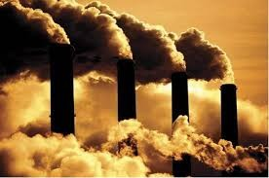

- Farming activities release greenhouse gases, which are methane released by livestock and nitrous oxide. The use of pesticides and herbicides also releases greenhouse gases into the atmosphere.

Reducing Impacts on Climate Change
Attempts have been made to reduce the impacts of change, especially from human activities. Pollution has been a major factor causing climate change. Adopting other energy methods like wind and solar power has been tried, but only a few have adopted them. Also, there was a ban on the burning of fossil fuels and deforestation. Infrastructural activities require timber, and this results in so many trees being cut down without replacement.
Despite all those efforts, some methods like governments initiating an emission control for vehicles, organizing tree planting days and educating the masses on the importance of mass tree planting, the government supporting the repair of old houses using other materials other than timber, banning the burning of fossil fuels, using alternative sources of energy such as solar energy and initiating composting programs where farmers are educated (Wang et al. 2018)

Conclusion
Climate change has had an adverse effect all over the world. This is a global problem affecting both developed and developing countries. This means that it is the government's task to continue campaigning for measures to curb the menace. Governments of both countries should collaborate and develop initiatives towards reducing the effect of global warming. This calls for the collective action of citizens and the government to reduce the impacts of climate change.

References
Longobardi, P., Montenegro, A., Beltrami, H., & Eby, M. (2016). Deforestation induced climate change: Effects of spatial scale. PloS one, 11(4), e0153357.
Mathew, E. K., Mohaddes, K., Ryan, N. C. Ng., Pesaran, M. H., Raissi, M., & Yang, J. C. (2019). Long-term macroeconomic effects of climate change: A cross-country analysis. NBER working paper (26167). http://www.nber.org/papers/w26167
Miller, D. D., Ota, Y., Sumaila, U. R., Cisneros‐Montemayor, A. M., & Cheung, W. W. (2018). Adaptation strategies to climate change in marine systems. Global Change Biology, 24(1), e1-e14.
Geruso, M. & Spears, D. (2018). Heat, humidity, and infant mortality in the developing
world. NBER working paper, (24870), 1-36. http://www.nber.org/papers/w24870

Wang, X., Bai, Z., Yao, Y., Gao, B., Chadwick, D., Chen, Q., ... & Ma, L. (2018). Composting with negative pressure aeration for the mitigation of ammonia emissions and global warming potential. Journal of Cleaner Production, 195, 448-457.

